Rural Health Appropriations Toolkit
Congress must prioritize vital rural health programs in order to support rural communities’ access to local care, sustain the rural health infrastructure, and bolster the workforce. NRHA urges Congress to fully fund rural health programs and pass a comprehensive FY 2027 budget.

NRHA has numerous ways for you to get involved and make your voice heard, all compiled here in our toolkit.

Table of Contents
- Advocacy Campaign: Urge Congress to Invest in Rural Health
  - Advocacy Campaign How-To Guide
- Template Letter to Members of Congress
- Rural Health Program Talking Points:
  - USDA Rural Hospital Technical Assistance Program
  - Flex Program
  - Rural Residency Planning and Development
  - Rural Health Care Outreach Services programs
  - Rural Communities Opioid Response Program
  - CDC Office of Rural Health
  - State Offices of Rural Health
- NRHA’s FY 2027 Appropriations Requests Table

You can also find these resources on our Appropriations Hub

Advocacy Campaign: Urge Congress to Invest in Rural Health
Use NRHA’s FY 2027 appropriations advocacy campaign to send an email directly to your senators and representative about the importance of fully funding rural health programs. Our advocacy campaigns include a pre-drafted message on rural health appropriations and an opportunity for you to personalize your email with your own story. Access the advocacy campaign here.

Advocacy Campaign How-To Guide
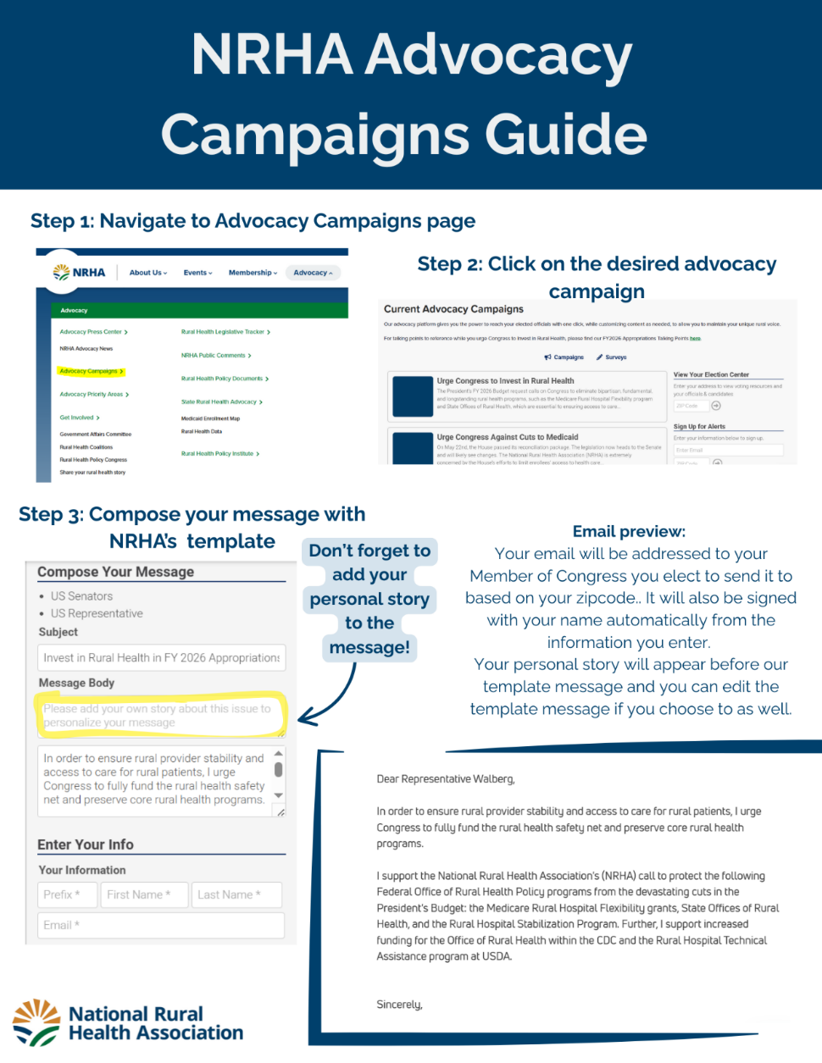

Template Letter to Members of Congress

Month X, 2026

Senator/Representative
U.S. Senate/U.S. House of Representatives
Office
Washington, DC 20510

Dear Senator/Representative XXX,

The (your organization) writes to encourage Congress to invest in rural health through increased or sustained funding for vital rural health programs that are essential to ensuring access to care in (state). Rural health spending is a relatively small percentage of the federal annual budget but is vitally important for maintaining access to care for individuals living in rural America. Congress must prioritize vital rural health programs in order to support rural communities’ access to local care, sustain the rural health infrastructure, and bolster the workforce. We urge Congress to fully fund rural health programs and pass a comprehensive FY 2027 budget.

(Paragraph introducing your organization, what you do, etc.)

Rural America is home to more than 62 million people whose access to care and economic stability depend on a strong healthcare infrastructure. Yet rural hospitals, clinics, and workforce pipelines continue to face unprecedented strain. Since 2010, over 200 hospitals have closed or discontinued inpatient services and over 40% of rural hospitals have negative operating margins, including XX in (state). When a rural hospital closes, not only does the community lose access to vital health care, but a major employer and community lynchpin exits, affecting the larger community. In 2026, Congress must prioritize funding vital rural health programs in order to support rural communities’ access to local care, sustain the rural health infrastructure, and bolster the workforce.

The following rural programs need continued investment to sustain rural healthcare access in our rural communities:

$125 for the Rural Hospital Provider Assistance Program. This new program, first funded in FY 2026, aims to help rural hospitals with low wage indexes by providing additional funding to support recruitment and retention. This program is a formula allocation that awards the same amount to each eligible hospital. In order to provide adequate awards to each rural hospital, we request $125 million for this program in FY 2027.

$5 million for the Department of Agriculture Rural Hospital Technical Assistance Program. The USDA TA program provides free, flexible, on-the-ground technical assistance to rural hospitals at-risk of closure to prevent closures and maintain essential healthcare services in rural communities. Over 130 rural hospitals have received or are receiving technical assistance since the pilot began in 2018. An estimated $1.7 million in financial opportunity is identified per project with an average project cost of $52,000.

$70.277 million for the Medicare Rural Hospital Flexibility (Flex) Program. The Flex program helps Critical Access Hospitals (CAHs) and rural communities deliver quality, sustainable healthcare. Flex is administered by the State Offices of Rural Health and supports training and technical assistance, financial and quality improvements efforts, and emergency medical services integration. Flex is a lifeline that keeps rural hospitals open and improves quality of care.

$14 million for the Rural Residency Planning and Development Program (RRPD). RRPD supports the development of new rural residency programs to address the ongoing workforce shortages faced by rural communities. Since 2019, this program has created 62 new accredited rural residency programs or rural track programs in family medicine, internal medicine, psychiatry, and general surgery.

$120 million for the Rural Health Care Services Outreach programs. This suite of programs support rural, community-driven initiatives that promote improved access to care, enhance care coordination, and foster sustainable solutions for chronic disease prevention and management in rural areas. In FY 2023, over 522,000 unique individuals received services through Outreach programs.

$145 for Rural Communities Opioid Response Program (RCORP). RCORP is a multi-year initiative that addresses barriers through targeted interventions for treatment for substance use disorder (SUD), including opioid use disorder (OUD), specific to the unique needs in rural areas.

$10 million for the Office of Rural Health at the Centers for Disease Control and Prevention (CDC ORH). The ORH enhances implementation of CDC’s rural public health portfolio, coordinates efforts across CDC programs, and has developed a strategic plan for rural public health. The CDC must have a permanent, central office to coordinate and streamline rural public health efforts across the agency.

$15 million for the State Offices of Rural Health (SORHs). SORHs across the country serve as the backbone of rural health coordination within their respective states. SORHs work with rural health care providers and stakeholders across the state to administer Flex programs, connect partners to resources, build capacity, and otherwise provide critical direct technical assistance.

$20 million for the Rural Hospital Stabilization Program. This is a pilot technical assistance program that improves health care in rural areas by providing in-depth assistance directly to financially distressed rural hospitals to address long-term solvency and operating models. The program provides direct funding to enhance and/or expand service lines.

(Your organization) appreciates your consideration of our concerns and urges you to invest in rural health care in the FY 2027 appropriations process. If you have any questions or would like to discuss the importance of these programs further, please contact (name) at (phone/email address).

Sincerely,

(E-Signature)

Name
Title
Organization

Rural Health Program Talking Points
For a more condensed version of talking points for these rural health programs, please reference NRHA’s Rural Health 2026 Advocacy Asks Talking Points.

USDA Rural Hospital Technical Assistance Program
The Rural Hospital Technical Assistance Program is a pilot technical assistance program at the U.S. Department of Agriculture (USDA) to improve rural hospitals’ financial and operational performance, prevent closures, and strengthen the delivery of healthcare in rural communities. The program provides direct on-the-ground assistance and is flexible enough to meet the varied needs of rural hospitals under operational and financial stress.
What does the program support?
Services available through the program include:
- Strategic, financial, and operational analysis
- Physician practice analysis
- Debt capacity with market assessment
- Revenue cycle management
- Service line analysis
Examples of projects include:
- Improving financial position and increasing operational efficiencies.
- Implementing quality improvements that support an evidenced-based culture for improved health outcomes.
- Increasing use of telehealth to fill service gaps and improve access to care.
- Strengthening the local health care delivery system to position for population health.
- Providing hospital board training through NRHA’s certification programs.

Why is this program needed?
- Since 2010, almost 200 rural hospitals have closed or stopped providing inpatient care.
- An additional 430+ hospitals are identified as vulnerable to closure.
- Almost half of rural hospitals have negative operating margins. For those with positive margins, the average operating margin is 1%.
- Technical assistance is a proven strategy to reduce closures and improve financial and operational performance.
The Rural Hospital Technical Assistance Program has boasted successful outcomes so far:
- USDA found that hospitals supported by Community Facilities programs, including the technical assistance program, were 94% less likely to close within 6 years.
- Nearly 130 rural hospitals have received or are receiving technical assistance since the pilot began in 2018.
- An estimated $1.7 million in financial opportunity is identified per project with an average project cost of $52,000.

Flex Program
Flex plays a critical role in helping (number) of Critical Access Hospitals (CAHs) in (your state) improve their financial status and focus on enhancing their quality of care. Congress created the Flex and SHIP programs as a bulwark against the structural challenges small rural hospitals face given their limited administrative capacity and resources. These programs ensure an annual support mechanism to support rural hospitals at a time when the risk of closure and financial stress is an ongoing problem.

The Flex program has a proven track record of improving the financial stability of small rural hospitals and participation in value-based efforts.
- As a result of targeted technical assistance to support CAH financial stability, the proportion of rural hospitals at high or mid-high risk of financial distress has decreased from more than 20% in 2019, to 17.8% in 2023.
- The percentage of CAHs participating in Accountable Care Organizations (ACOs) increased from 30% in 2021 to 40% in 2025.
  - As of January 2026, 590 CAHs are participating in the Medicare Shared Savings Program.

Flex funding builds capacity for CAHs to participate in the Medicare Beneficiary Quality Improvement Project (MBQIP) measures by supporting essential investments in data infrastructure and reporting capabilities.
- Facilitating data transparency, benchmarking, and peer learning—leading to CAHs outperforming national peers on patient experience and quality measures.

Flex funding provides infrastructure support that allows small rural hospitals to strengthen financial and operational performance and invest in activities that improve access to high quality care in rural areas. Example investments support:
- Medicare cost reports analysis to identify ways to enhance their reimbursement and receive the appropriate level of payment for the services they provide.
- Updates to the hospital’s Chargemaster, which identifies the appropriate market value for services and makes sure hospitals set prices that reflect their competitive market.
- Helping hospitals complete meaningful Community Health Needs Assessments
- Participation in the Rural Health Clinic (RHC) Compliance Cohort and mock survey support in preparation for RHC recertification.
- Support critical Emergency Medical Services (EMS) provider training, agency sustainability, and quality improvement efforts.

The Flex program supports education and training to invest in clinical staff and caregivers which rural hospitals don’t have funding to otherwise provide. These efforts, in turn, raise the level of care provided at independent rural hospitals. Training activities include: on-site obstetric simulation training in order to maintain local access to care; crisis prevention training to protect rural healthcare workers; and training for billing staff in coding and billing to ensure the hospitals can bill efficiently for their services, increasing cash flow and improving their financial status.

Rural Hospital Status and Impact
If Flex is not supported rural hospitals will be more at risk of closure:
- Loss of funding for financial analysis would result in hundreds of rural hospitals falling behind on their billing practices and lose the ability to continuously analyze and update their revenue cycle management.
- Rural hospitals will face significant hurdles in quality data collection and reporting, disqualifying them from key payment models and driving a widening gap between rural and urban systems.
- The quality improvement efforts play a key role in supporting the ability of rural hospitals to take part in value-based care models, which already lags behind urban hospitals. The loss of this funding will exacerbate that participation gap.
- When quality challenges emerge for rural hospitals, it helps reinforce the bypass factor, where patients with private insurance drive past their local hospital for care, leaving only patients with Medicare, Medicaid or uninsured, leading to further hardship.

Nationally, nearly 50% of rural hospitals operate with negative profit margins. Since 2010, almost 200 rural hospitals have closed or ceased inpatient services.
- In (your state) XX rural hospitals are operating with a negative profit margin.

When a rural hospital closes, not only does the community lose access to vital health care, but a major employer and community lynchpin ends, affecting the larger community. Investing in a strong rural health infrastructure is critical to the future of rural areas.

Bottom line, Flex is an important maintenance program that rural hospitals count on each year to provide the resources that help rural hospitals to keep their doors open and ensure a focus on providing high quality care.

Rural Residency Planning and Development Program
The Rural Residency Planning and Development Program (RRPD) provides start-up funding to establish new and grow existing rural residency programs. Find RRPD-funded programs in your state here.
Why is RRPD important?
- Despite only 2% of Medicare Graduate Medical Education training occurring in rural areas, graduates of rural residency programs are 5.4 times as likely to choose rural practice.
- Training in a rural area is the best predictor of a physician choosing to practice in a rural community.
- Training residents in rural areas immediately increases access to care. Residents are physicians that can see and treat patients with counsel from rural health care preceptors.
- X programs in (your state) are funded by RRPD.
What does RRPD do?
- Provides grants of up to $750,000 to help hospitals establish rural residency training programs, including rural track programs.
- Funding can help support the costs of accreditation, faculty development, and resident recruitment, including both direct and indirect costs.
- RRPD can help establish a residency training program in one of the following needed rural specialties:
  - Family medicine
  - Internal medicine
  - Preventive medicine
  - Psychiatry
  - General surgery
  - Obstetrics and gynecology
What is RRPD’s track record of improving access to care?
- Since the pilot program began in 2019 RRPD grantees have:
  - Established 62 new accredited rural residency programs or rural track programs in family medicine, internal medicine, psychiatry, and general surgery.
  - Created 752 approved new residency positions in rural areas, with over 660 enrolled.
  - Made awards to 103 grantees across 36 states and 1 territory.
- You can access these statistics on an RRPD one pager here.

Rural Health Care Services Outreach programs
Outreach grant programs improve rural community health by focusing on enhancing access to care, quality improvement, care coordination, and integration of services. This is done through a suite of programs that allow grantees flexibility to best determine how to meet community needs. Further, Outreach programs encourage longevity by providing initial start-up funding and then requiring recipients to identify and implement strategies to continue the projects after federal funding ends. For more information, please reference NRHA’s Rural Services Outreach Program fact sheet.
Outreach programs include:
- Rural Health Care Services Outreach Program
- Rural Health Network Development Program
- Rural Maternity and Obstetrics Management Strategies (RMOMS)
- Small Health Care Provider Quality Improvement Grants
- Rural Health Care Coordination Program
Outreach programs also help to address regional challenges through the following:
- Delta States Rural Development Network Grant Program
- Delta Region Community Health Systems Development Program
- Delta Maternal Care Coordination Program
- Rural Northern Border Region Outreach Program
- Appalachian Region Healthcare Support Program
Outreach programs show proven, successful outcomes:
- In FY 2023, 522,000 unique individuals received direct services through Outreach programs.
- In FY 2022, 85% of grantees showed improvement in one or more clinical measures.
  - Clinical measures include reductions in diabetic hemoglobin A1c scores (HgbA1c), blood pressure scores, tobacco use, and body mass index (BMI) calculations.
- In FY 2023, 100% of Delta States Rural Network Development grantees showed improvements on at least one clinical measure.
- Rural Health Network Development Program grantees generated an average of $2.00 of economic impact into their rural communities for every Outreach program dollar spent.
- In FY 2023, 98% of Rural Health Network Development Program grantees reported that they will sustain all or parts of their projects.

Rural Communities Opioid Response Program
Rural Communities Opioid Response Program (RCORP) is a multi-year initiative aimed at reducing the morbidity and mortality of substance use disorder (SUD), including opioid use disorder (OUD), in high-risk rural communities. For more information, please reference NRHA’s RCORP fact sheet.
Specifically, the RCORP program funds planning and implementation efforts relevant to rural communities related to medication assisted treatment, neonatal abstinence syndrome, psychostimulant support, overdose response, and child, adolescent, and adult behavioral health support.
RCORP programs show proven, successful outcomes:
- In FY 2023, RCORP awarded $80 million across 39 states to support key strategies to respond to the overdose risk from fentanyl and other opioids.
- In FY 2024, $14 million went towards grantees improving access to treatment and recovery services for substance use disorder and opioid use disorder.
- In 2022, RCORP served 2 million individuals across more than 1,900 communities in 47 states/territories.
- RCORP-supported rural counties had 1.2 more waivered clinicians per 100,000 population to prescribe buprenorphine, which is a medication for opioid use disorder. RCORP counties also had 57.5 more treatment slots per 100,000 population compared to non-RCORP counties.

CDC Office of Rural Health
The CDC Office of Rural Health (ORH) was created in the FY 2023 appropriations bill. The Office enhances implementation of CDC’s rural public health portfolio, coordinates efforts across CDC programs, and has developed a strategic plan for rural public health that maps the way forward.

Rural residents experience a higher likelihood of death from leading chronic diseases and unintentional injury. This is due to the fact that rural areas experience unique health challenges and are more impacted by socioeconomic drivers of health and environmental hazards in comparison to their urban counterparts. Thus, rural public health efforts and interventions must be specifically catered to address rural population health. The CDC must have a permanent, central office to coordinate and streamline rural public health efforts across the agency.

State Offices of Rural Health
- Federally funded since 1991, the SORH Program assists states in strengthening rural health care delivery systems by maintaining a focal point for rural health in each state.
  - These cost-effective programs directly improve health care access and outcomes for rural residents.
  - SORHs are trusted partners of rural hospitals and providers across the state – ensuring programs like Flex and SHIP are not just administered but truly impactful. Not only do SORHs administer these programs, but they do also it well because of long-term relationships with hospitals and healthcare providers in the state.

- The program provides funding for an institutional framework helps small rural communities leverage state and federal resources to develop long-term solutions to rural health programs.
  - Leverage the initial investment to secure additional investments rural health programming (insert information available from your state. Example: from Michigan shows a 27 fold return on investment from federal funding ($237k to $6.4m))
  - The SORH program is not just a Federal program. It's a Federal-state partnership with a 3-to-1 match requirement, meaning for every federal dollar invested, states contribute three dollars. This cost-sharing model ensures shared responsibility, maximizes the impact of federal funds, and reflects strong state-level commitment to rural health.

- The SORH program provides foundational funding to support core staffing and operations that enables states expand workforce development, primary care access, and continuing education statewide. Example activities investments support include:
  - Workforce Development: Educating future and current health professionals about practicing in rural communities. Supporting "grow-your-own" pipeline programs for high-need roles—from lab technicians to advanced clinicians.
  - Ensuring Primary Care Access:
    - Building financial and operational sustainability for certified Rural Health Clinics and other rural providers.
    - Supporting quality improvement efforts that address chronic conditions like kidney and cardiovascular disease
  - Provider Education: Offering a trusted, low-cost education model to improve rural care delivery. Delivering continuing education credits annually through Grand Rounds and Project ECHO programs (focusing on infectious disease, One Health, and diabetes)

NRHA FY 2027 Appropriations Requests
You can access this information as a one-pager here
FY 2027 Rural Health Discretionary Appropriations Requests

Discretionary Funding Program | NRHA FY 2027  Request | Bicameral FY 2026 | President’s FY 2026 Budget | FY 2026  Continuing Resolution
Federal Office of Rural Health Policy Programs
Rural Health Research & Policy Development | $14M | $11.076M | $11.076M | $11.076M
Rural Hospital Provider Assistance Program New! | $125M | $25M | N/A | N/A
Rural Hospital Stabilization Pilot Program | $20M | $14M | $0 | $4M
Rural Hospital Flexibility Grants | $70.277M | $70.277M | $0 | $64.277M
State Offices of Rural Health | $15M | $13.5M | $0 | $12.5M
Rural Health Care Services Outreach, Network & Quality Improvement Grants | $120M | $110.975M | $100.975M | $100.975M
Rural Maternity & Obstetrics Management Strategies Program(s) | $15M | $15M | -- | $12M
Rural Residency Planning & Development | $14M | $14M | $12.7M | $12.7M
Rural Communities Opioid Response | $145M | $145M | $145M | $145M
Critical HRSA Safety Net Programs
National Health Service Corps | $160M | $130M | $474M | $128.6M
Area Health Education Centers | $47M | $47M | $0 | $47M
Nursing Workforce Development | $320M | $305.472M | $0 | $305.472M
Oral Health Training | $43.673M | $43.673M | $0 | $41M
Behavioral Health Workforce Development Programs | $261M | $114M | $89.3M | $193M
Teaching Health Center GME* | $250M | $225M | $175M | $164M
Telehealth | $48M | $45.5M | $42M | $42.05M
Community Health Centers | $1.858B | $1.858B | $1.738B | $1.858B
340B Drug Pricing Program/Office of Pharmacy Affairs | $12.24M | $12.24M | $12.24M | $12.24M
Centers for Disease Control and Prevention
Office of Rural Public Health | $10M | $6M | -- | $5M
USDA Rural Development Programs
Rural Hospital Technical Assistance | $5M | -- | $0 | $2M
Communities Facilities Loans and Grants | $1.6B | $1.25B | $1.9B | $1.6B
Broadband ReConnect Program | $112.4M | $50.75M | $0 | $90M

https://www.ruralhealth.us/advocacy/state-rural-health-advocacy/rural-health-data
https://www.hrsa.gov/rural-health/opioid-response/fy2023-rcorp-awards-overview#:~:text=August%2031%2C%202023%3A%20the%20U.S.,from%20fentanyl%20and%20other%20opioids.
https://www.hrsa.gov/rural-health/opioid-response/impact/fy24-awards
https://grants.hrsa.gov/2010/Web2External/Interface/Common/EHBDisplayAttachment.aspx?dm_rtc=16&dm_attid=3c0e8d19-eea5-41bb-82e6-4d726c8e7a67&dm_attinst=0

