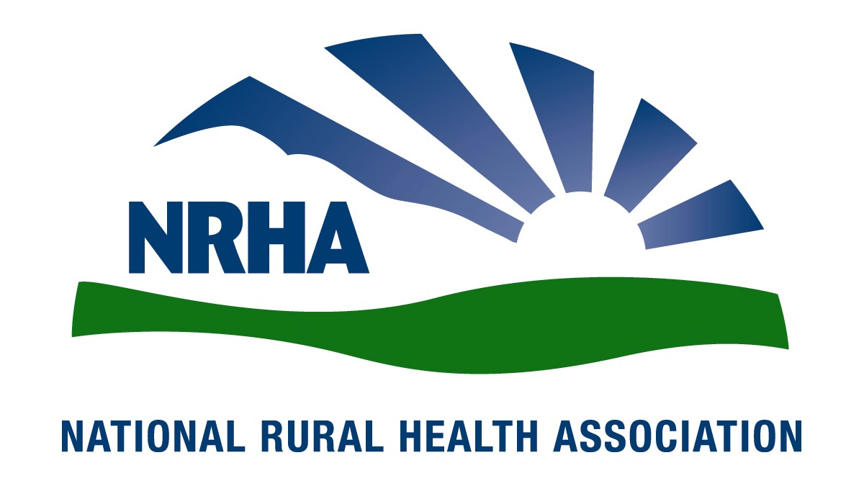
Headquarters
521 E. 63rd St.
Kansas City, Mo. 64110
816-756-3140
Government Affairs Office
1108 K Street NW
2nd Floor
Washington, D.C. 20005
202-639-0550

For immediate release Contact: Lindsey Corey
May 11, 2010 corey@NRHArural.org
816-756-3140 x. 22
NRHA announces 2010 Rural Health Award recipients

The National Rural Health Association (NRHA) is proud to announce its 2010 Rural Health Award recipients. The ceremony will honor the following organizations and individuals May 20 during the 33rd Annual Rural Health Conference, which will attract 900 rural health professionals and students to Savannah, Ga.

“We’re especially proud of this year’s winners,” said Alan Morgan, NRHA CEO. “They have each already made tremendous strides to advance rural health care, and we’re confident they will continue to help improve the lives of rural Americans.”

Appalachian Regional Healthcare, based in Lexington, Ky., is the 2010 Outstanding Rural Health Organization.

“What started out as a group of union hospitals for miners has grown into a remarkable health system of 4,700 employees serving one the country’s most medically underserved areas,” Morgan said. “More than 50 years after its founding, Appalachian Regional Healthcare has overcome obstacles to continue its mission in the mountains offering residents of eastern Kentucky and southern West Virginia a local option for quality care.”

Pike County Community Health Partnership is this year’s Outstanding Rural Health Program.

“Started just three years ago, this partnership in western Illinois has made great strides to improve health access and awareness in a county with high poverty and limited health care options,” Morgan said. “From mental and oral health to transportation and prevention programs, Pike County’s partnership is a great example of how collaboration fosters positive change in rural America.”

Rup Nagala, MD, is NRHA’s 2010 Practitioner of the Year. Nagala is a physician at Southeast Medical Center in Oakes, N.D., and a clinical assistant professor at the University of North Dakota School of Medicine. He helped establish a network of seven rural clinics and sponsored the education of nine physician assistants to staff the clinics and provided leadership in the construction of the area’s first assisted living center, a new hospital and a dialysis center.

“Rup has served patients in rural North Dakota since he completed his residency more than 30 years ago,” Morgan said. “He has worked tirelessly to enhance the quality of life for residents of southeastern North Dakota and shown what can be done if there is a will to do what is right and necessary.”

Michael Samuels, DPh, will receive the Distinguished Educator of the Year Award. He is professor and chair of the A.T. Still University School of Health Management’s master’s in public health program and emeritus endowed chair and distinguished scholar in rural health policy and research and professor of family and community medicine at the University of Kentucky College of Medicine.

“Mike is a teacher of teachers who has kept the spirit and substance of rural health alive for succeeding generations to build on in the quest for better health for rural residents,” Morgan said. “His contribution to rural health will continue for generations to contribute to a healthier rural America.”

Robin Rose will receive the Louis Gorin Award for Outstanding Achievement in Rural Health. Rose is chief nursing officer at Gibson Area Hospital and Health Services in Gibson City, Ill.

“Like Louis, Robin has given more than 17 years of creativity and compassion in improving health care,” Morgan said. “She’s stayed true to her rural roots, keeping current nursing licensure in Kentucky to expand her knowledge base on rural health care. But Robin has truly found her calling serving rural residents in and around Gibson City. Staff and patients there are lucky to have her leadership.”

Amy Dore, a recent Central Michigan University doctor of health administration graduate, will receive the 2010 Student Achievement Award.

“Amy’s passion for the challenges of rural health is impressive, and her initiative, enthusiasm and commitment in exploring advantages and disadvantages of delivering surgical services in small rural hospitals were extraordinary,” Morgan said. “She didn’t conduct her research at arm’s length. Amy got up close and personal at Pauls Valley General Hospital in Oklahoma. Her research wasn’t about getting her degree but about a strong commitment to community.”

Michelle Clark-Forsting, a University of Wisconsin student, will receive the organization’s Student Leadership Award.

“Michelle has worked to develop NRHA’s first student-only constituency group to increase the role of students in our organization,” Morgan said. “Her leadership and vision have successfully generated a home for all students interested in rural health care within NRHA.”

John Snow Inc. provides a scholarship to each of the students to attend the conference.

NRHA is a nonprofit organization working to improve the health and well-being of rural Americans and providing leadership on rural health issues through advocacy, communications, education and research. NRHA membership is made up of 20,000 diverse individuals and organizations, all of whom share the common bond of an interest in rural health.

www.RuralHealthWeb.org

