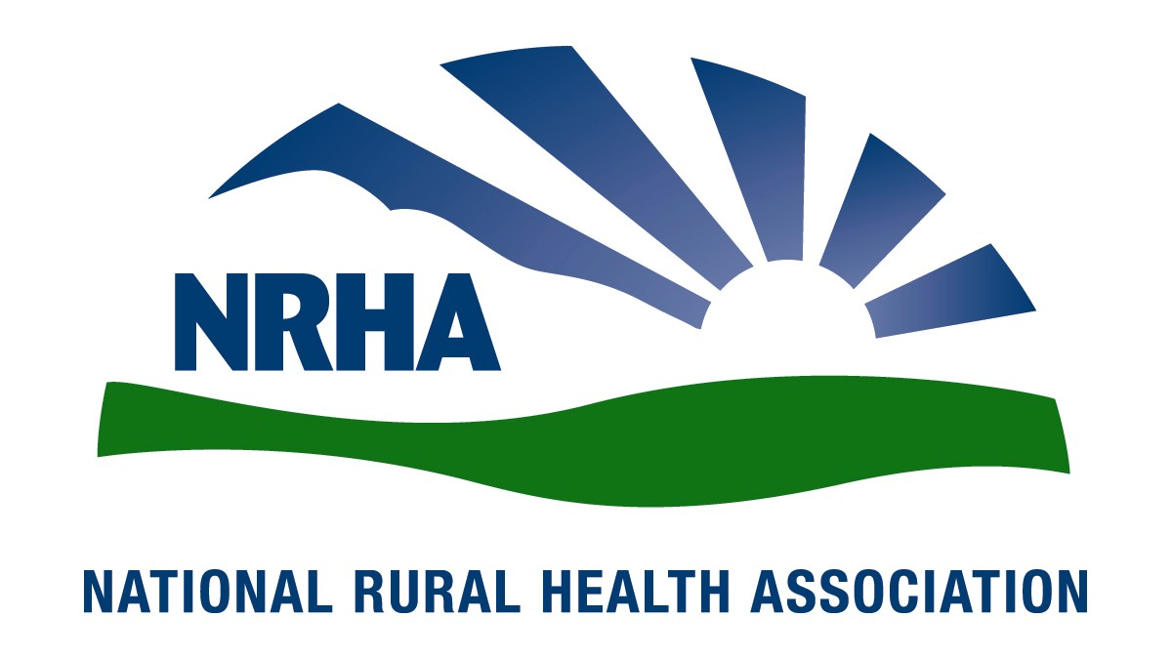
Headquarters
521 E. 63rd St.
Kansas City, Mo. 64110
816-756-3140
Fax: 816-756-3144

Government Affairs Office
1108 K Street NW
2nd Floor
Washington, D.C. 20005
202-639-0550
Fax: 202-639-0559

For immediate release Contact: Lindsey Corey
Dec. 8, 2008 816-756-3140 x. 22

2009-2010 NRHA Rural Health Congress elected

The National Rural Health Association (NRHA) is pleased to announce its 2009-2010 Rural Health Congress.
New members are Mark Chustz, Michael Hagen, Thomas Henton, Roger Masse, Rhett Carver Partin, David Pearson, Elizabeth Schnettler, Eric Shell, Kristina Sparks, Susan Starling and W.M. Woods.
“I’m excited about the dynamic team elected by their peers to take the lead in policy changes vital to improving health care for rural Americans,” NRHA CEO Alan Morgan says.
The Rural Health Congress is the NRHA’s policy-making body. It is made up of elected representatives from each of the association’s nine constituency groups, its State Association Council, its State Office Council, its Issue Groups and the association’s officers. This grassroots representation reflects the concerns of the NRHA membership. The Rural Health Congress determines the association’s positions on public policy through policy briefs and issue papers.

The NRHA is a nonprofit organization working to improve the health and well-being of rural Americans and providing leadership on rural health issues through advocacy, communications, education and research. The NRHA membership is made up of 18,000 diverse individuals and organizations, all of whom share the common bond of an interest in rural health.

www.RuralHealthWeb.org

