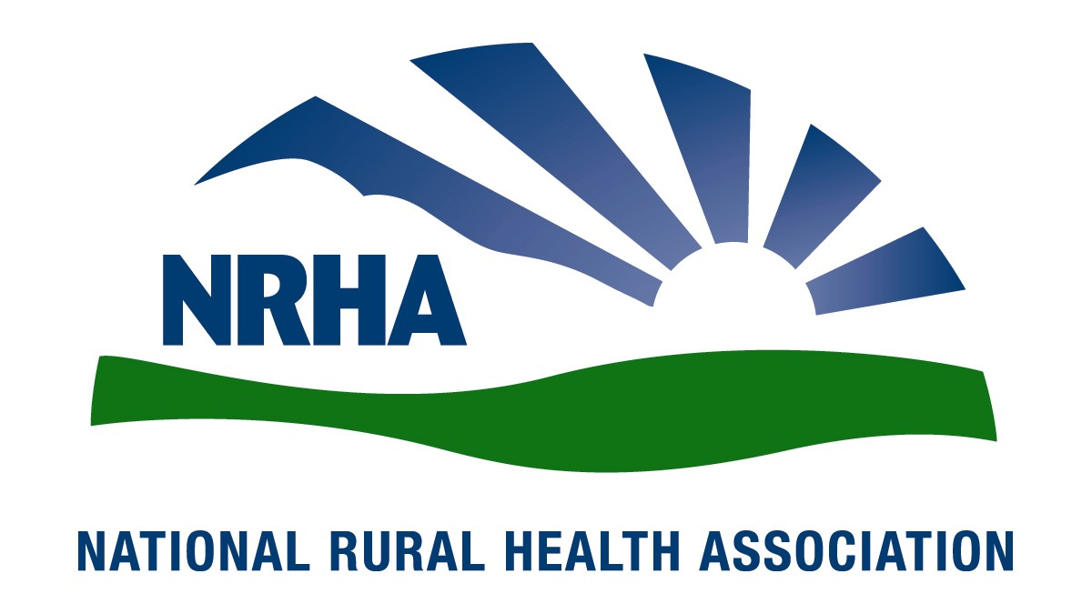
Headquarters
521 E. 63rd St.
Kansas City, Mo. 64110
816-756-3140
Fax: 816-756-3144

Government Affairs Office
1108 K Street NW
2nd Floor
Washington, D.C. 20005
202-639-0550
Fax: 202-639-0559

For immediate release Contact: Lindsey Corey
Dec. 3, 2008 816-756-3140 x. 17

Berens named president-elect of National Rural Health Association

National Rural Health Association (NRHA) members have elected Dennis Berens their 2009 president-elect.

Berens has been an active NRHA member since his rural health career began in 1990 when he became director of the Nebraska State Office of Rural Health. He continues in that position today.

“The NRHA is excited about Denny’s new leadership role,” NRHA CEO Alan Morgan says. “He’s a true advocate for improved health care for rural Americans.”

Berens facilitated the formation of the Nebraska Rural Health Association in partnership with the NRHA. He has also participated in each of the NHRA’s annual Rural Health Conferences and Rural Health Policy Insititutes for the past 18 years.

In addition to serving on NRHA committees and presenting at educational conferences, Berens is a member of the National Rural Health HIT Coalition and has served on the National EMS/Trauma Advisory Board for Health Resources and Services Administration.

“Rural health is a mission, not a job,” Berens says. “The National Rural Health Association has a special place in America today because it is the large tent where the many mission-driven partners and stakeholders come together to share our challenges and our successes and advocate for changes to fix problem policies and models. We work to link our resources to find ways for rural communities and people to be heard and helped. The opportunities for rural America may never be greater than what they could become now.”

The NRHA is a nonprofit organization working to improve the health and well-being of rural Americans and providing leadership on rural health issues through advocacy, communications, education and research. The NRHA membership is made up of 18,000 diverse individuals and organizations, all of whom share the common bond of an interest in rural health.

www.RuralHealthWeb.org

