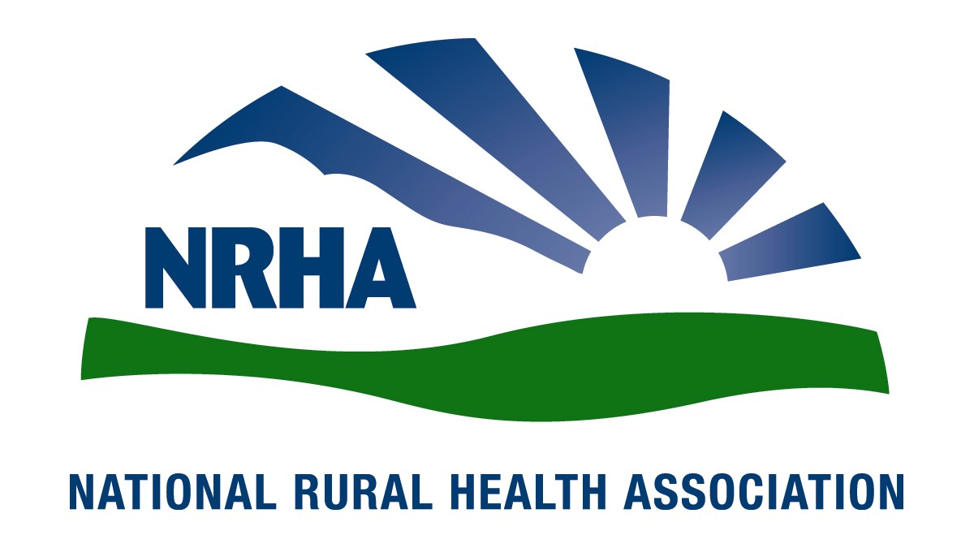
Headquarters
521 E. 63rd St.
Kansas City, Mo. 64110
816-756-3140
Fax: 816-756-3144

Government Affairs Office
1108 K Street NW
2nd Floor
Washington, D.C. 20005
202-639-0550
Fax: 202-639-0559

For immediate release Contact: Amy Elizondo
Jan. 25, 2010 202-639-0550

NRHA Strengthens Focus on Community Health Status

On Jan. 23, the National Rural Health Association (NRHA) Board of Directors unanimously voted to enhance the organization’s focus on health status and public health by establishing a constituency group dedicated to community health status.

With the consent of group members, the organization’s former Community Grassroots Constituency Group has been expanded and refocused to become the Community Health Status Constituency Group. The group’s charge is to “represent members interested in effecting community level change to improve the health status of rural citizens.”

“This is a natural progression of NRHA’s interest in population and public health that began in 2001 when the organization dedicated the theme of its annual conference to Rural Public Health, to 2004 when it established its Rural Public Health Interest Group, creating a home for members interested in population health. The Community Health Status Constituency Group is the next step in formalizing NRHA’s commitment to population and public health,” said Michael Meit, the constituency group’s chair.

NRHA CEO Alan Morgan called the move critical and explained that it allows for additional organizational voice and benefits, including representation on the Board of Trustees and a seat on NRHA’s policy-making body, the Rural Health Congress.

Meit said he’s honored to lead the expanded group.

“NRHA members with an interest in communitywide health improvement, public health and population-level interventions now have a formal home within NRHA’s structure,” he said. “Even more importantly, this group provides the opportunity to expand our membership to include those in the fields of public and population health. This helps us to bring more people into the rural health tent, allowing us to think more broadly about approaches to achieving our shared goal of improving the health status of all rural citizens.”

NRHA is a nonprofit organization working to improve the health and well-being of rural Americans and providing leadership on rural health issues through advocacy, communications, education and research. The NRHA membership is made up of 18,000 diverse individuals and organizations, all of whom share the common bond of an interest in rural health.

www.RuralHealthWeb.org

