Z
Government Affairs Office
1025 Vermont Ave. NW
Suite 1100
Washington, D.C. 20005
202-639-0550
Fax: 202-639-0559
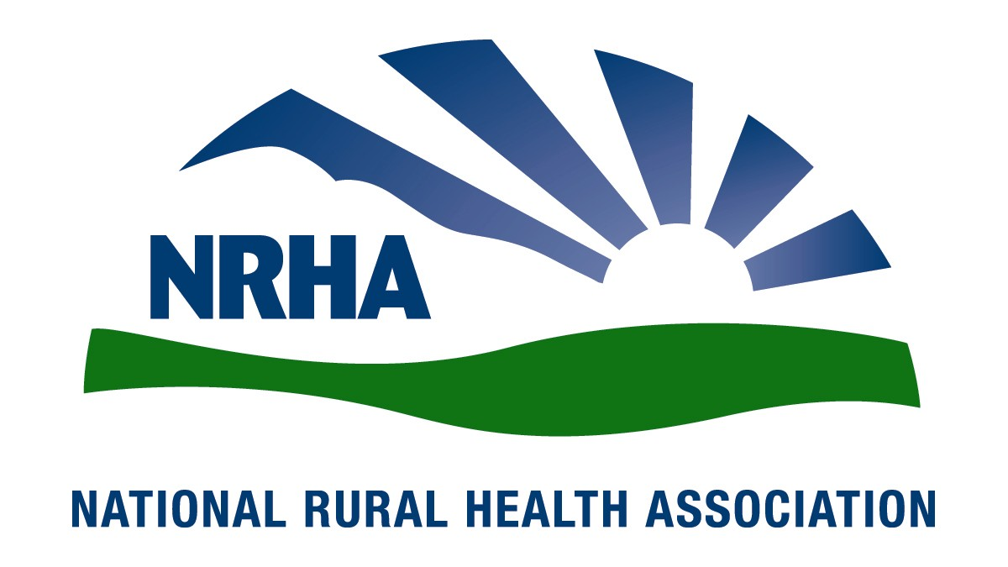
Headquarters
4501 College Blvd, #225
Leawood, KS 66211
816-756-3140
Fax: 816-756-3144

October 2017

Seema Verma
Administrator
Centers for Medicare and Medicaid Services
Hubert H. Humphrey Building
200 Independence Avenue, SW, Room 445‐G
Washington, DC 20201

Re: Center for Medicare and Medicaid Innovation: Request for Information on Centers for Medicare & Medicaid Services: Innovation Center New Direction

Dear Administrator Verma:

The National Rural Health Association (NRHA) is pleased to respond to the request for information (RFI) regarding the Center for Medicare and Medicaid Innovation (CMMI) New Direction. We appreciate your continued commitment to the needs of the 62 million Americans residing in rural and underserved areas, and look forward to our continued collaboration to improve health care access and quality.

The National Rural Health Association (NRHA) is a non-profit membership organization with more than 21,000 members nation-wide that provides leadership on rural health issues. Our membership includes nearly every component of rural America’s health care infrastructure, including rural community hospitals, critical access hospitals, rural health clinics, federally qualified health centers, doctors, nurses and patients. We work to improve rural America’s health needs through government advocacy, education and research.

NRHA shares CMS’s overall goal of fostering “an affordable, accessible healthcare system that puts patients first.” Rural populations and their providers of care are faced with challenges that cannot be ignored and are uniquely well suited for demonstration projects through the CMMI.

Rural Americans are more likely to be older, sicker and poorer then their urban counterparts. Specifically, they are more likely to suffer with a chronic disease that requires monitoring and follow up care, making convenient, local access to care necessary to ensuring patient compliance with the services that are necessary to reduce the overall cost of care and improve the patients’ outcomes and quality of life. A January 2017 CDC study indicates that “the death rate gap between urban and rural America is getting wider.” The rates of the five leading causes of death — heart disease, cancer, unintentional injuries, chronic respiratory disease, and stroke — are higher among rural Americans. Yet, many rural Americans live in areas with limited health care resources, restricting their available options for care, including primary care. Seventy-seven percent of rural counties in the U.S. are Primary Care Health Professional Shortage Areas while nine percent have no physicians at all. Rural seniors are forced to travel significant distances for care, especially specialty services. CMMI provides an opportunity for unique rural focused programs that address the rural specific challenges including the workforce shortages, sicker and poorer patient populations, geographic barriers, and low patient volumes to provide new approaches to providing and paying for care.

Success can only truly be achieved by moving away from an all-or-nothing, one size fits all model where a community either is able to sustain a hospital (based on generating a sufficient volume that encourages a ‘heads in beds’ mentality) and accompanying medical care or resulting in the community losing direly needed local access to health care services. Importantly, in rural communities it is essential to go beyond the status quo and look to patients not currently receiving care at the locally, both those receiving care elsewhere and those forgoing care, and those services currently not offered locally. Flexibility will promote cost and operational efficiencies and provide value in the provision of local and regional services, while allowing facilities to best serve their community.

NRHA supports and encourages the use of rural centric transformation initiatives.

Without question there was unanimity around the notion of DSR initiatives planned for and implemented in rural communities. There is an appetite for a demonstration similar to that of the Essential Access Community Hospital/Rural Primary Care Hospital (EACH-RPCH) program and Medical Assistance Facility (MAF) program operated between 1991 and 1994. These two programs combined was the precursor to the Critical Access Hospital (CAH) program passed in the Balanced Budget Act (BBA) of 1997. The evidence suggests that the CAH program stabilized the financial operations of over a thousand rural hospitals resulting in relatively few closures between 2000 and 2010. Unfortunately, due to a plethora of factors including Medicare cuts that because of the patient population they serve disproportionately impact rural communities, since 2010 over 80 rural hospitals have closed and a third of all rural hospitals are vulnerable to closure.

As a result, there is an appetite for demonstrations today that with a vision and ingenuity can provide vibrant and meaningful health care in rural communities. We are historically a very similar place to where we were in 1994. The parallels are striking.

It is important to categorize rural hospitals and their related clinics as to their operational status. This ensures that solutions to the problems facing rural communities and their healthcare systems are targeted, appropriate, and most likely to be successful. The three categories defined by rural stakeholders are as follows
- At-risk or soon to be at at-risk facilities (cliff or slope). This cohort of hospitals represent systems of care in rural communities that include employing physicians and other health professionals that would go away once these facilities close, destroying any chance of evolving these facilities into the next generation of delivery models.
- Stable facilities with sound strategic fundamentals. This is the middle of a bellshaped curve. These facilities are at lower risk of closure in the near term, however, if the current trends prevail with little or no intervention, they could become at high risk in the long-term. These facilities need technical assistance and rural focused policies to transition into the next generation of delivery and payment system reforms. With smaller patient populations, this cohort of hospitals requires a longer transition period with an understanding that initial investments are often cost prohibitive for these providers and focus on immediate savings without considering the cost to the provider are inappropriate and miss the greater opportunity for better value through improved outcomes and necessary utilization.
- High-performers or first-movers. These communities have begun to implement alternative payment models, for example ACOs, they have strong leadership and community involvement. These communities tend to have healthier patient populations with fewer sociodemographic risk factors. They face the challenges of low volume and require ways to modify or work within existing programs that work with their patient volumes and geographic limitations.

In consideration of one cohort for purposes of illustration, NRHA learned from its stakeholders
that a possible DSR initiative for the “at-risk” cohort of hospitals that CMMI could operate as a
demonstration is a new provider type called the “Community Outpatient Hospital” or COH. This
demonstration would allow currently licensed CAHs or small PPS Hospitals to convert to a COH
with the Conditions of Participation (COP) as follows (for example only):
- Traditional ambulatory/clinic services
- Care coordination and chronic disease management
- Emergency Department Care (telemedicine allowed required)
- Transitional Care, to include an observation capacity for up to 24 or 48 hours
- Emergency Medical Services (EMS)/non-emergent medical transportation
- No acute inpatient capacity
- Community-based health needs planning within a population health framework
This model has been characterized in summary fashion as a “bedless CAH.” This DSR
demonstration would yield savings as well as scalability, two required features of a CMMI innovation project. While this model is not appropriate for all at risk facilities, for some communities this would provide an opportunity to retain necessary medical care.

NRHA supports broad access to data. NRHA found that access to Medicare Shared Savings Program (MSSP) data for rural communities would be valuable in their transition to population health practices. Currently, a rural community provider has to participate in the MSSP program as an Accountable Care Organization (ACO) in order to gain access to these data files. Any DSR demonstration or initiative should include full access to their community’s MSSP data files for purposes care coordination and planning.

Thank you for the chance to offer a response to this RFI on the new direction for the CMMI. NRHA looks forward to greater CMMI engagement with rural providers to create more rural specific demonstration projects that will allow rural providers to continue to provide necessary local care in their communities. We very much look forward to continuing our work together to ensure our mutual goal of improving quality of and access to necessary care in rural America. If you would like additional information, please contact Diane Calmus at dcalmus@nrharural.org, or 202-639-0550.

Sincerely,
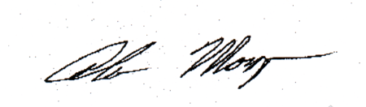

Alan Morgan
Chief Executive Officer
National Rural Health Association

