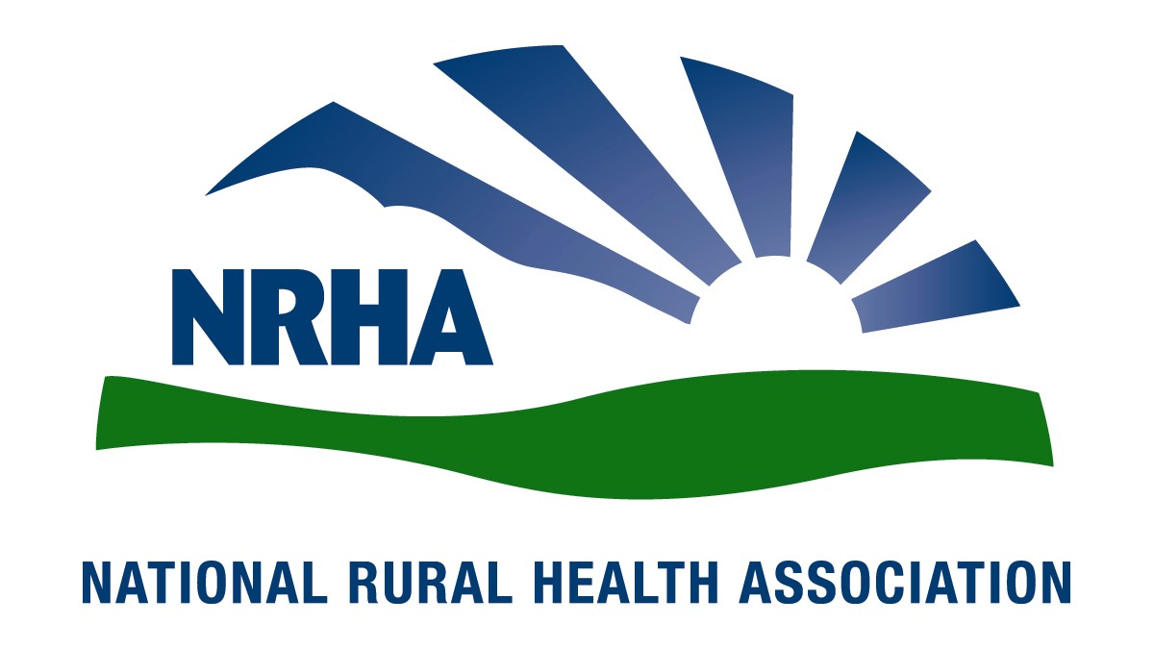
Headquarters
521 E. 63rd St.
Kansas City, Mo. 64110
816-756-3140
Fax: 816-756-3144

Government Affairs Office
1108 K Street NW
2nd Floor
Washington, D.C. 20005
202-639-0550
Fax: 202-639-0559

For immediate release Contact: Amy Elizondo
Dec. 8, 2008 202-639-0550

NRHA announces 2009 Rural Health Fellows
The National Rural Health Association (NRHA) is pleased to announce the final selections for the 2009 Rural Health Fellows program. After the completion of a competitive review process, 12 fellows were selected to participate in this year-long, intensive program aimed at developing leaders who can articulate a clear and compelling vision for rural America.
“We are very pleased to announce this new class of fellows as this program enters its third year. Once again, this class represents various levels of rural health care expertise,” NRHA CEO Alan Morgan says. “With the successes achieved by the 2007 and 2008 classes, we look forward to continuing the tradition of building rural health care leaders through this valuable program.”
The new Rural Health Fellows are:
Evonne Bennett, capacity building specialist, Office of Minority Health Resource Center, Rockville, Md.
Katherine Brewer, MPH, administrative fellow and practice manager, University of Pittsburgh Medical Center, Pittsburgh
Barbara Cliff, RN, MHSA, MPA, president/CEO, Cheboygan Memorial Hospital, Cheboygan, Mich.
Amy Ham, program specialist, California Telemedicine and eHealth Center, Sacramento, Calif.
Loretta Heuer, PhD, RN, FAAN, professor and department chair, University of North Dakota College of Nursing, Grand Forks
Fiorella Horna-Guerra, program consultant, Office of Rural Health and Community Care, Raleigh, N.C.
Trent Howard, second year student, DeBusk College of Osteopathic Medicine, Powell, Tenn.
Terri Hurst, MSW, policy analyst, Colorado Rural Health Center, Aurora, Colo.
Carole Pratt, DDS, dentist, American Dental Association, Dublin, Va.
Andrea Radford, DrPH, MHA, research fellow, North Carolina Rural Health Research and Policy Analysis Center, Chapel Hill
Laurissa Stigen, MS, executive director, Central Minnesota Area Health Education Center, Fergus Falls
Alan West, PhD, health scientist, Veterans Affairs Medical Center, White River Junction, Vt.
The NRHA is a nonprofit organization working to improve the health and well-being of rural Americans and providing leadership on rural health issues through advocacy, communications, education and research. The NRHA membership is made up of 18,000 diverse individuals and organizations, all of whom share the common bond of an interest in rural health.

www.RuralHealthWeb.org

